# SDR JOVE ADC and FPGA Assembly Instructions

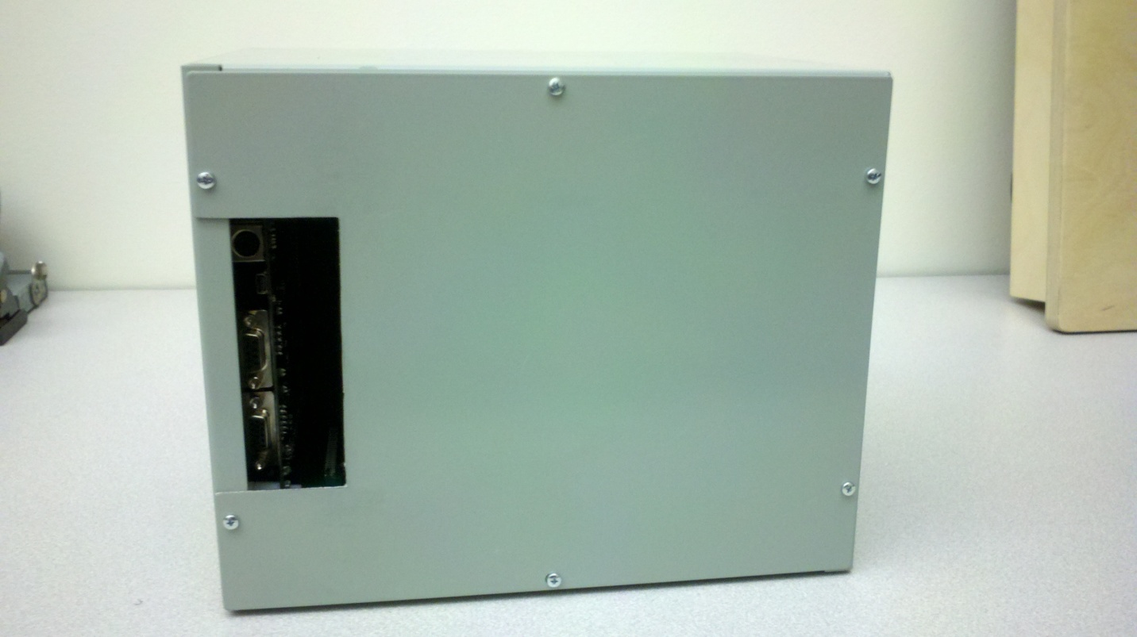

Grand Valley State University  
EGR 486 – Senior Project  
Dan Soberal  
Sean Bredeweg  
Phil Behnke

Hardware:

|  |  |  |
| --- | --- | --- |
| Image | Item | Quantity |
| 2011-08-02_21-01-17_867.jpg | #4-40, Hexagonal 0.5” Length Nylon Standoffs | 8 |
| 2011-08-02_21-02-57_19.jpg | #4-40 Steel Nut | 4 |
| 2011-08-02_21-03-20_898.jpg | #4-40, 0.250" Length Machine Screw | 4 |
| 2011-08-02_21-09-04_415.jpg | M3, Hexagonal 10MM Length Nylon standoffs | 8 |
| 2011-08-02_21-12-32_625.jpg | M3 Steel Nut | 4 |
| 2011-08-02_21-13-07_267.jpg | M3, 5MM Length machine screw | 4 |
| 2011-08-02_21-14-19_189.jpg | 6" SMA Male-Male Connector | 1 |
| 2011-08-02_21-17-04_751.jpg | #6-32 Enclosure Fastening screws | 12 |

Tools required:

* Small Philips Screwdriver
* Small Slotted Screwdriver
* Small Crescent wrench

Procedure:

1. Combine the eight 10mm, M3 Nylon standoffs into four 20mm standoffs.
2. Take the FPAG board facedown (the Digilent and Nexys2 logos are face down) and place the four M3 Standoffs through the holes on the corners.
3. Take the four M3 nuts and tighten them down on the standoffs.

**IMPORTANT:** The nuts are made of metal and the standoffs are made of a softer material, Nylon. Make sure that the nut is threading properly on the standoff and not stripping the threads. Damaging the threads on the standoffs can affect the stability of FPGA when mounted in the enclosure.

1. With the FPGA face down and supported by the standoffs, connect the adapter board to the FPGA as depicted in Figure 1. Ensure that the board is seated firmly against the FPGA.

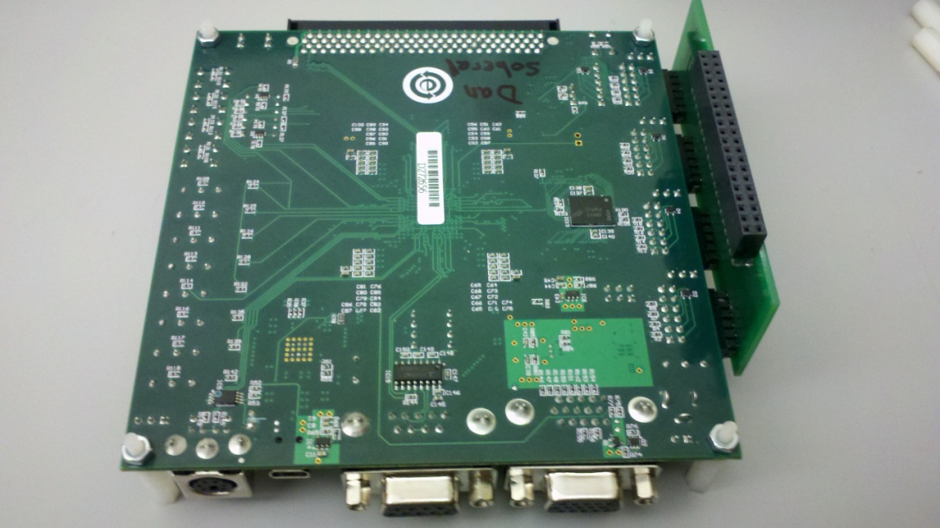  
Figure 1: Standoffs and adapter board mounted on the FPGA

1. Take the ADC board and connect it to the adapter board as shown in Figure 2.

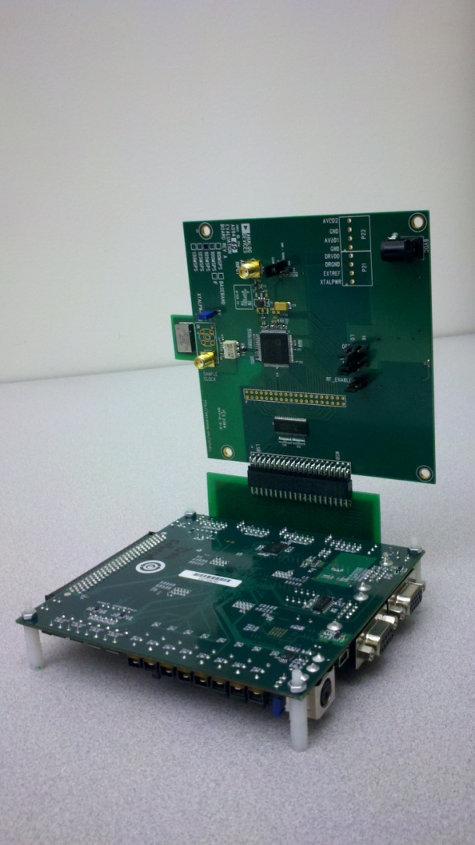  
Figure 2: ADC connected to the FPGA

1. Take the eight #4-40 nylon standoffs and combine them the same way as in step 1.
2. Take the four standoffs and mount them inside the enclosure to the bottom face using the four #4-40 machine screws. Refer to Figures 3 and 4.  
   **IMPORTANT:** Again, be careful not to strip the threads on the inside of the standoff. If you are having difficulty threading into the standoff, remove the screw and try again.

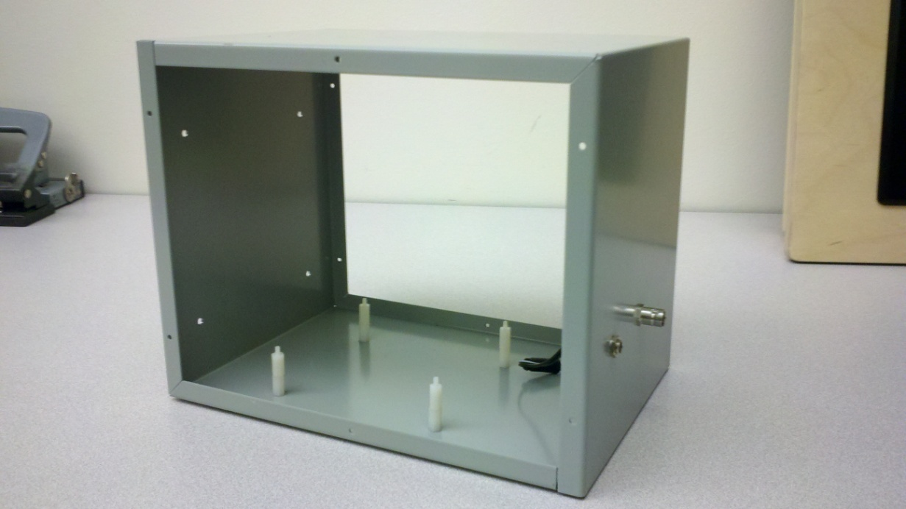  
Figure 3: ADC standoffs mounted on bottom of enclosure

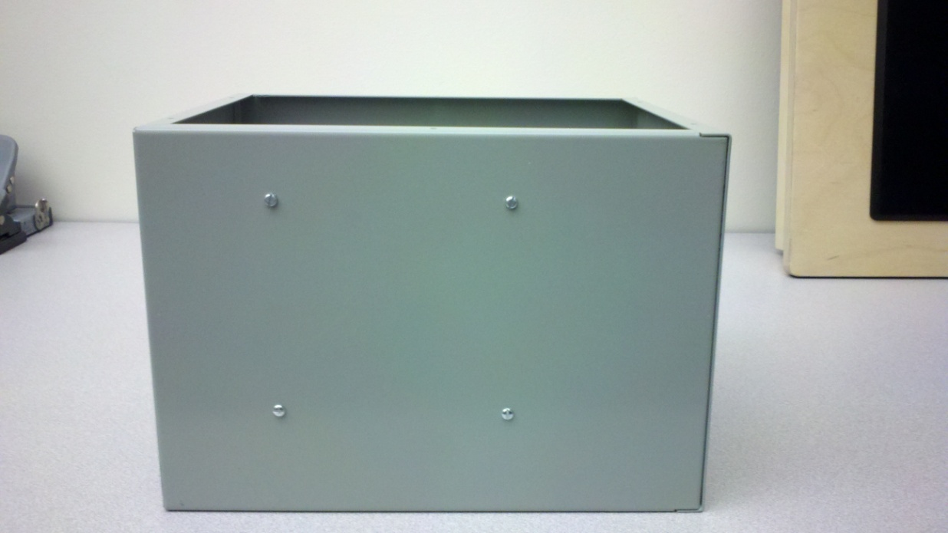  
Figure 4: Bottom view showing the screws for the ADC standoffs

1. Take the board assembly and place it inside the box, orientating it so that the ADC board is parallel to the standoffs on the bottom, and the standoffs secured to the FPGA are aligned with the holes opposite the power jack and BNC connector.
2. Line up the four standoffs installed on the bottom of the enclosure with the four holes located in the corners of the ADC board. The ADC board should sit directly on top of the standoffs. Refer to Figure 5.

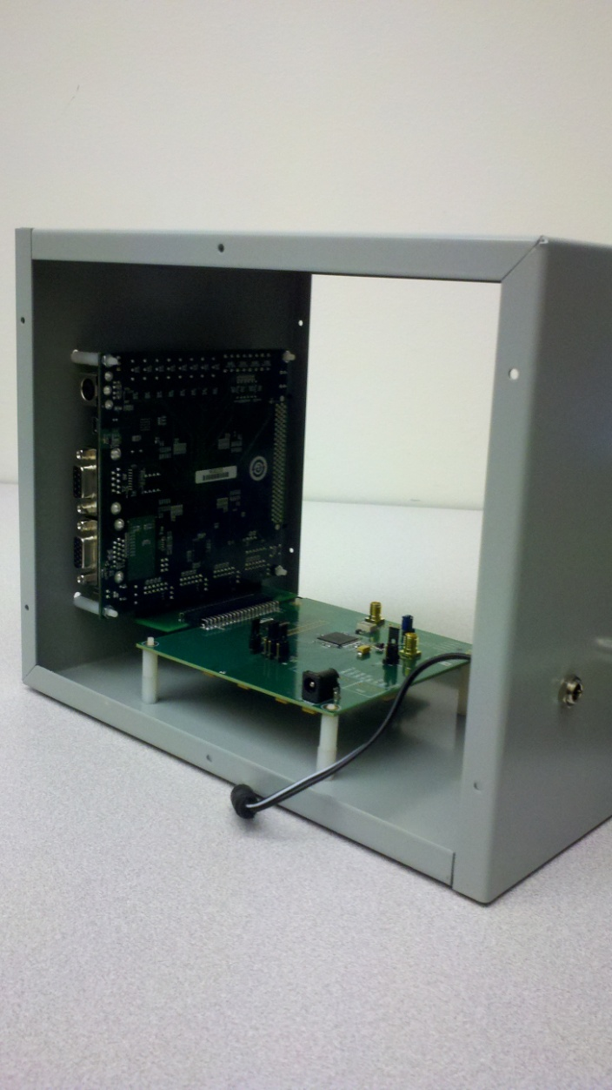  
Figure 5: ADC resting on the standoffs

1. Thread the four #4-40 nuts onto the standoffs, securing the ADC to the bottom of the enclosure. Refer to Figure 6.

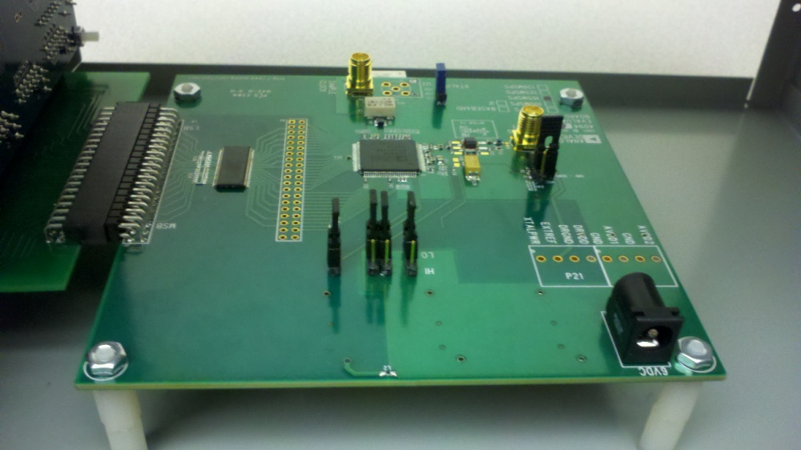  
Figure 6: ADC secured to standoffs

1. Take the four M3 screws and begin to secure the FPGA board to the side of the box. Refer to Figure 7.

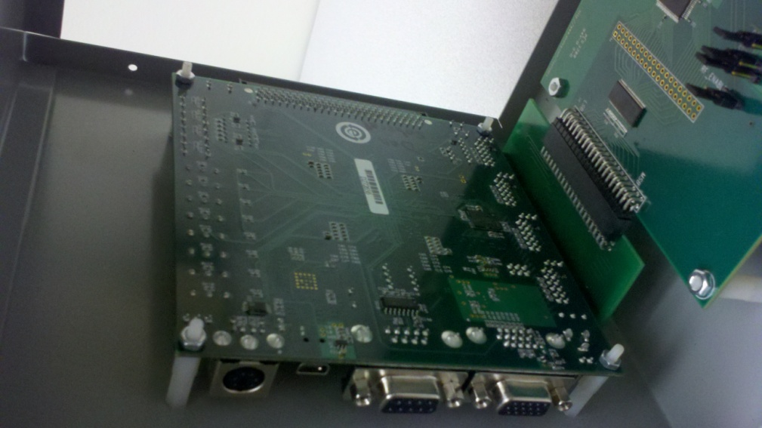  
Figure 7: FPGA secured to the side of the enclosure

1. Connect the barrel connector to the ADC board. Connect one end of the 10” SMA cable to the analog input of the ADC, and the other end to the panel mounted SMA connector. Refer to Figure 8.

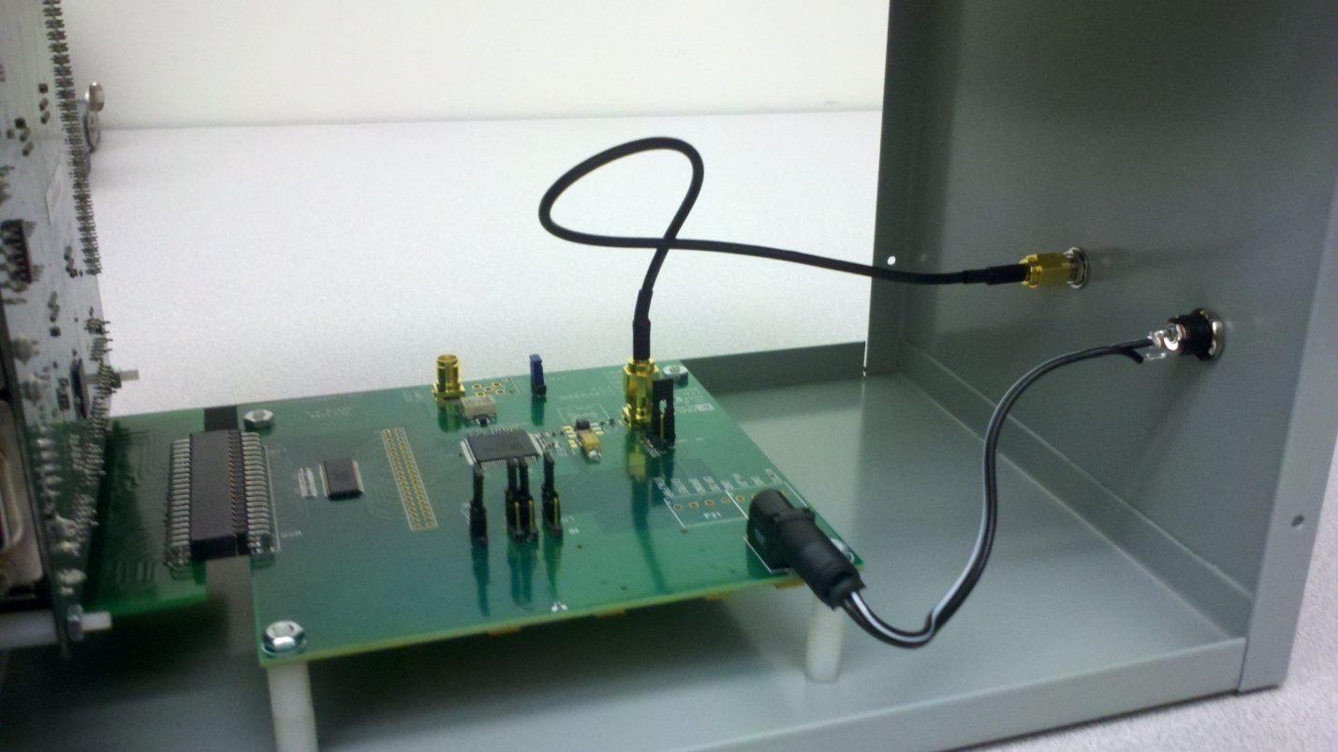  
Figure 8: Barrel connector and SMA cable connected

1. Install the full face plate using six of the #6-32 enclosure fastening screws. The full face plate needs to be on the side opposite the ADC’s barrel connector.
2. Take the faceplate with the cutout and orientate it so that the opening lines up with the USB connection on the FPGA. Install the faceplate using the remaining six enclosure fastening screws. Refer to Figure 9.

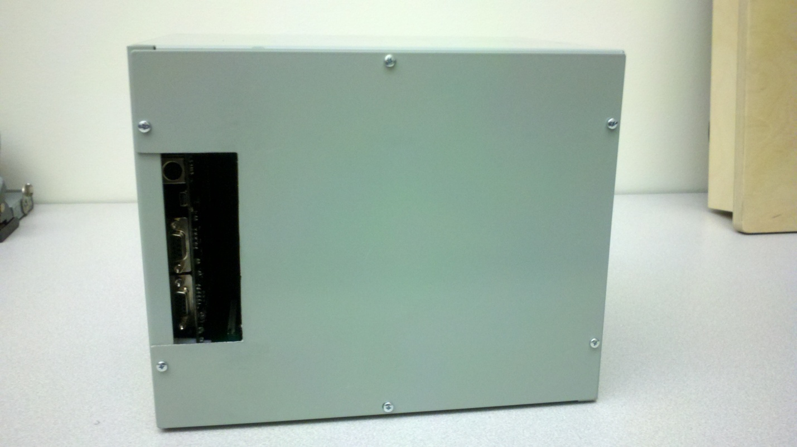  
Figure 9: Side view of the enclosure showing the cutout and the FPGA peripherals